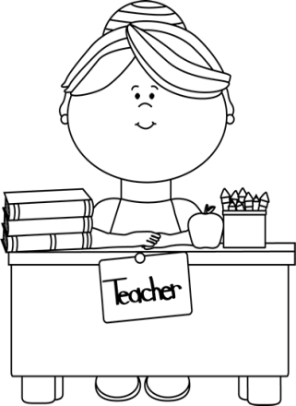

**Sixth Grade**

**Language Arts**

**Information for Parents**

**Welcome!**

Welcome to sixth grade! My name is Mrs. Woods, and I will be your child’s language arts teacher this year. I am excited to work with your child and help him or her be successful. We have lots of ambitious goals this year, including reading 1500 pages each; achieving 80% or higher on every test, quiz, project, and homework assignment; learning 150 new words, including 16 affixes; and passing Virginia’s SOL reading assessment. Please encourage your child to meet these goals. We will work hard but will also have a lot of fun!

**Contact Information**

Communication is so important for a successful year. Please do not hesitate to contact me if you have questions or concerns.

E-mail: swoods@gilesk12.net

Phone: 626-7281

You will also be hearing from me throughout the school year. Your child will be bringing home a parent information sheet where you can let me know how you would prefer to be contacted.

**Remind App:**

To receive periodic texts concerning happenings in 6th grade, text @4aa39a to the number 81010

You will receive a welcome text from Remind. If you have trouble with 81010, you can also try texting @4aa39a to (601) 910-4181.

Class Website and Blog

Sixth grade maintains a website with valuable information about all of your child’s subjects. Please check it frequently to learn about homework, upcoming activities, and special happenings.

The link for our website is: **eems6thgrade.weebly.com/**

and you can also find a link on EEMS’s homepage.

Additionally, the sixth grade students will maintain our Language Arts blog where they will record daily events and reflections. You can reach the blog from my Weebly page or directly at: http://woodssixth.weebly.com/

Mrs. Woods’ Schedule

8:10-8:30 ~ Homeroom, Silent Reading Time

8:30-9:00 ~ Choir (Library on Wednesdays)

9:00-9:50 ~ Reading 1

9:50-10:40 ~ Reading 2

10:40-11:30 ~ Reading 3

11:30-12:10 ~ Writing 1

12:10-12:40 ~ Lunch

12:40-1:20 ~ Writing 2

1:20-2:00 ~ Writing 3

2:00-2:30 ~ PE

2:30-3:00 ~ Band (Keyboarding on Tuesdays)

3:00 ~ Dismissal

Homework and Grading

**Homework**

Students will receive homework assignments every Monday, and all homework (except Reading Logs) will be due on Friday. In general, your student will have the following homework assignments every week:

* Vocabulary and word root study homework
* Practice SOL reading passage and comprehension questions
* Either a writing or grammar assignment

**Independent Reading and Reading Logs**

In order for your child to become a better reader, he or she *must* practice reading in texts he or she can and wants to read. As such, students will be required to complete at least 15 minutes of independent reading each night. Please make a commitment to helping your child complete this independent reading.

I will track independent reading through a reading log that will be due on Mondays. We will go over the format for the reading logs in class and that information will be posted on the Language Arts website. Students will choose their first independent reading materials during the first week of school, and the first reading log entry will be due on Friday, September 14.

**Grading**

Students receive a grade for reading class and writing class. In general, tests and projects will count for 40% of students’ grade; quizzes will count 30%; homework counts 20%; and class participation counts for 10% of students’ grade.