Poetry Project
Due:
Directions
For this project, you will choose a poem to analyze and then identify poetic elements and create a visual image of that poem.
Process
1. Choose a poem to analyze. It can be any poem… but choose one that you really like and is interesting to you. Make sure that the poem is long enough to contain some of the poetic elements below.
2. Read through the poem several times to make sure you understand it.
3. Find and label all poetic elements you can find. Your poem must have at least three poetic elements. Examples of poetic elements include:
- simile
- metaphor
- hyperbole
- personification
- alliteration
- onomatopoeia
- rhyme
- repetition

4. Find and circle at least three images that the poem creates in your mind.

5. Now you’re ready to put the project together. Using a piece of thick paper (poster or cardstock), design a shape that represents your poem and cut the paper into that shape.

On the front of your paper:
- Copy the poem you chose. Use your very best handwriting.
- Underline and label the poetic elements you found. You must find at least three!

On the back of your paper:
- Draw pictures representing the three images you found in the poem. Beside the images, write the line or lines from the poem that the images represent.

Sample Project

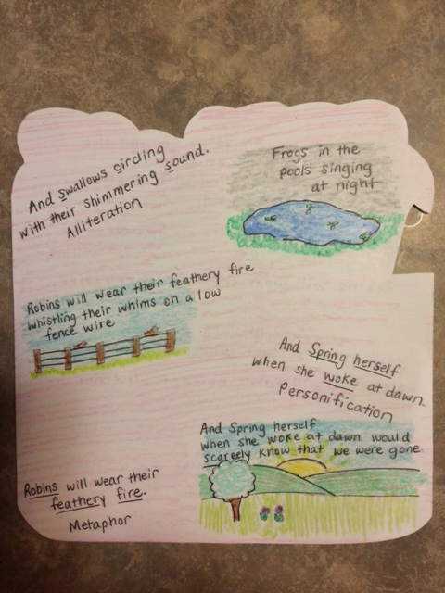
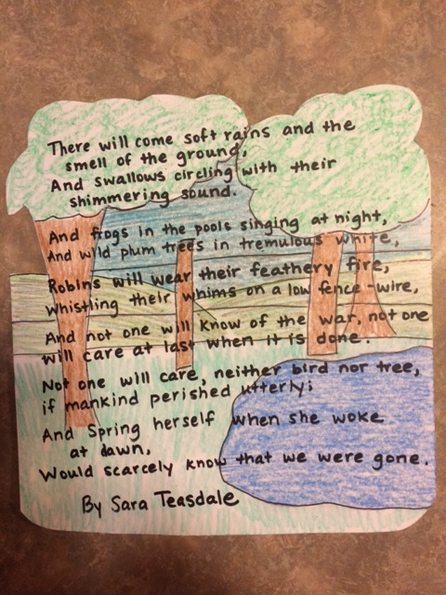

Poetry Project
_____ Shape of paper represents poem (15 pts.)
_____ Poem copied neatly on paper (15 pts)
_____ 3 Poetic Elements labelled (30 pts)
_____ 3 Pictures representing images from poem (30 pts)
_____ Project is neat and colorful (10 pts.)

Poetry Project
_____ Shape of paper represents poem (15 pts.)
_____ Poem copied neatly on paper (15 pts)
_____ 3 Poetic Elements labelled (30 pts)
_____ 3 Pictures representing images from poem (30 pts)
_____ Project is neat and colorful (10 pts.)

Poetry Project
_____ Shape of paper represents poem (15 pts.)
_____ Poem copied neatly on paper (15 pts)
_____ 3 Poetic Elements labelled (30 pts)
_____ 3 Pictures representing images from poem (30 pts)
_____ Project is neat and colorful (10 pts.)

Poetry Project
_____ Shape of paper represents poem (15 pts.)
_____ Poem copied neatly on paper (15 pts)
_____ 3 Poetic Elements labelled (30 pts)
_____ 3 Pictures representing images from poem (30 pts)
_____ Project is neat and colorful (10 pts.)

